Julie Sweany

Lab 3

March 19, 2018

IT1150, CRN13094

# Table of Contents

Table of Contents 2

Executive Summary 3

Chapter 5, Exercise 5-1 4

Chapter 5, Exercise 5-2 11

Halloween Exercise 5 12

Chapter 6, Exercises 6-1 and 6-2 18

Chapter 6, Exercise 6-3 26

Halloween Exercise, Part 2 35

Conclusion 42

Resources 43

# Executive Summary

The exercises in this lab provided experience creating layouts for web pages using the box model and CSS.

In the box model, there are four properties that can be set to different sizes to control how things are spaced. First, there is a width and height for the content itself. Around that, extra space can be indicated. This area is known as the padding. Around the padding, a border can be included. Finally, around the border, additional space can be included, and this area is known as the margin.

CSS is used to assign values to the various components of the box model. Additionally, CSS can be used to assign float properties to specified elements, causing the block elements to appear side by side on the page.

The box model and CSS offer a lot of flexibility in terms of the kinds of layouts and visual aesthetics they can produce, and these exercises provided a valuable introduction.

# Chapter 5, Exercise 5-1

Exercise 5-1 provides experience using the box model to control spacing, borders, and backgrounds. Using the web page created in Exercise 4-1 as a base, changes were made to the page that illustrate the box model concept.

First, the body was set to a width of 600 pixels. This was done by adding a width property to the previously created rule set for styling the body selector. Then, the margins were adjusted to 0 on the top and bottom and to auto on the sides with the margin: property. Setting the sides to auto centered the body within the browser window.

The border: property was used a few different ways in this exercise. It was first used to create a border around the body. This was a standard border, surrounding the whole perimeter. Later in the exercise, the border-top: and border-bottom: were used to add borders, but this time, limited to just to the specified sides of the box.

The exercise also provided a lot of experience working with padding to adjust the spacing around elements. A reset selector was used to remove the default margins and padding, and then new rule sets were created according to the requested values to be used for various elements. Padding can be applied evenly on all sides of a particular element, or different values can be applied to the top, bottom, and sides of the box. This can be determined by the number of values used (one produces equal padding all the way around, two determine top/bottom and right/left, three indicate top, sides, bottom, and four are used to indicate values for top, right, bottom, and left). Alternately, the padding-top:, padding-right:, padding-bottom:, and padding-left: properties can be used.

Background colors and gradients were used throughout this exercise, as well. Setting the body’s background color, using the background-color: property, changed not only the background of the body, but also of the entire area within the browser window. This was corrected by adding a rule set to the CSS file, indicating that the html element should have a white background. Adding a background color to the footer further reinforced the lesson on background colors.

Using gradients is similar to indicating background colors, but it is a little more involved. For gradients, the background-image: property is used, followed by linear-gradient and, in parentheses, several values. The first value indicates the direction for the gradient, and it is followed by a color and a percentage to indicate what area the color should be appearing within, and at least one more color and percentage combination. Multiple colors can be used, and a wide variety of gradient combinations can be produced. Linear gradients are a newer addition to CSS, and, for now, it’s necessary to add prefixes in order for them to be processed correctly by different browsers. Safari and Chrome require –webkit-, Firefox requires –moz-, and Opera requires –o-.

The exercise wrapped up with an instruction to do some experimenting and to further adjust the look of the page. I further adjusted the gradient in the header, also adding the color from the borders. I also added a little more padding after the blockquote, and to the left of the images and links for the speakers. I finished by adding a top and bottom margin around the main 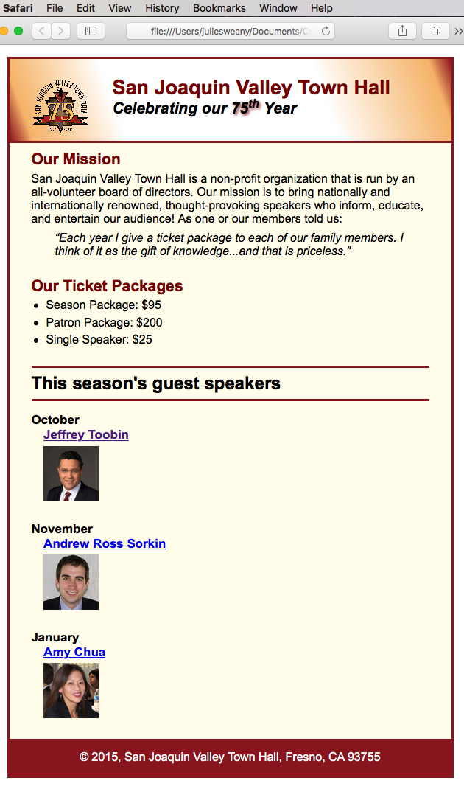element.

The screenshot included to the left shows the completed page for Exercise 3-1 in the Safari browser.

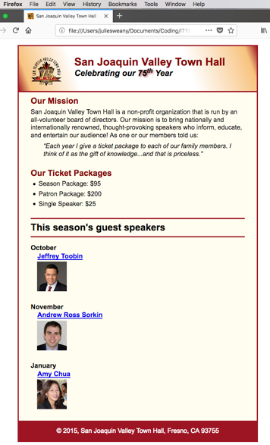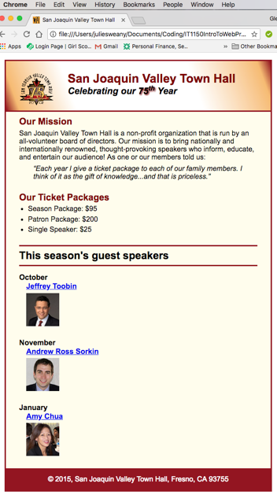Below are screenshots of the completed page displayed in the Chrome and Firefox browsers. Differences were extremely slight.

HTML for Exercise 5-1

Index.html

<!DOCTYPE html>

<html lang="en">

<head>

<meta charset="utf-8">

<title>San Joaquin Valley Town Hall</title>

<link rel="shortcut icon" href="images/favicon.ico">

<link rel="stylesheet" href="styles/normalize.css">

<link rel="stylesheet" href="styles/main.css">

</head>

<body>

<header>

<img src="images/town_hall_logo.gif" alt="Town Hall Logo" height="80">

<h2>San Joaquin Valley Town Hall</h2>

<h3>Celebrating our <span class="shadow">75<sup>th</sup></span> Year</h3>

</header>

<main>

<h2>Our Mission</h2>

<p>San Joaquin Valley Town Hall is a non-profit organization that is run by an all-volunteer board of directors. Our mission is to bring nationally and internationally renowned, thought-provoking speakers who inform, educate, and entertain our audience! As one or our members told us:</p>

<blockquote>&ldquo;Each year I give a ticket package to each of our family members. I think of it as the gift of knowledge...and that is priceless.&rdquo;</blockquote>

<h2>Our Ticket Packages</h2>

<ul>

<li>Season Package: $95</li>

<li>Patron Package: $200</li>

<li>Single Speaker: $25</li>

</ul>

<h1>This season's guest speakers</h1>

<h3>October<br><a href="speakers/toobin.html">Jeffrey Toobin</a></h3>

<img src="images/toobin75.jpg" alt="Toobin Photo">

<h3>November<br><a href="speakers/sorkin.html">Andrew Ross Sorkin</a></h3>

<img src="images/sorkin75.jpg" alt="Sorkin Photo">

<h3>January<br><a href="speakers/chua.html">Amy Chua</a></h3>

<img src="images/chua75.jpg" alt="Chua Photo">

</main>

<footer>

<p>&copy; 2015, San Joaquin Valley Town Hall, Fresno, CA 93755</p>

</footer>

</body>

</html>

CSS for Exercise 5-1

main.css

/* reset selector */

* {

margin: 0;

padding: 0;

}

/* the styles for the elements */

html {

background-color: #ffffff;

}

body {

background-color: #fffded;

width: 600px;

margin: 1em auto 1em;

border: 3px solid #931420;

font-family: Arial, Helvetica, sans-serif;

font-size: 100%;

}

/* the styles for the header */

header {

background-image: linear-gradient(20deg, #931420 0%, #f6bb73 5%, #ffffff 25%,

#ffffff 70%, #f6bb73 95%, #931420 100%);

background-image: -webkit-linear-gradient(20deg, #931420 0%, #f6bb73 5%, #ffffff 25%, #ffffff 70%, #f6bb73 95%, #931420 100%);

background-image: -moz-linear-gradient(20deg, #931420 0%, #f6bb73 5%, #ffffff 25%, #ffffff 70%, #f6bb73 95%, #931420 100%);

background-image: -o-linear-gradient(20deg, #931420 0%, #f6bb73 5%, #ffffff 25%, #ffffff 70%, #f6bb73 95%, #931420 100%);

border-bottom: 3px solid #931420;

padding: 1.5em 0 2em;

}

header img {

float: left;

padding: 0 30px 0;

}

header h2 {

font-size: 170%;

color: #800000;

}

header h3 {

font-size: 130%;

font-style: italic;

}

.shadow {

text-shadow: 2px 2px 4px #800000;

}

/* the styles for the section */

main {

clear: left;

padding: 0 30px 0;

}

main h1 {

font-size: 150%;

border-top: 3px solid #931420;

border-bottom: 3px solid #931420;

padding: .3em 0;

}

main h2 {

font-size: 130%;

color: #800000;

padding: .5em 0 .25em;

}

main h3 {

font-size: 105%;

padding-bottom: .25em;

}

main img {

padding-bottom: 1.5em;

padding-left: 1em;

}

main p {

padding-bottom: .5em;

}

main blockquote {

padding: 0 2em 1em;

font-style: italic;

}

main ul {

padding: 0 0 .25em 1.25em;

}

main li {

padding-bottom: .35em;

}

/* the styles for links */

a:hover, a:focus {

font-style: italic;

}

main a {

padding-left: 1em;

}

/* the styles for the footer */

footer p {

text-align: center;

color: white;

padding: 1em 0;

}

footer {

background-color: #931420;

padding: 1em;

}

# Chapter 5, Exercise 5-2

Exercise 5-2 changed the border around “This season’s guest speakers” to a double border on all sides with rounded corners, and it also added a shadow.

These changes were made using the border:, border-radius:, and box-shadow: properties within the CSS for the main h1 elements.

The completed exercise in Safari (top), Chrome (middle), and Firefox (bottom). Safari gives the double border a lighter look than the other two browsers, displaying lighter lines with more space In between.



The section of the CSS that was modified for Exercise 5-2.

main h1 {

font-size: 150%;

border: 5px double #931420;

border-radius: 10px;

padding: .3em 0;

box-shadow: 5px 5px 2px #931420;

text-indent: .5em;

}

# Halloween Exercise 5

This exercise reinforced the concepts covered in Exercise 5-1.

One difference between this and the previous exercise, is that this one includes a background image behind the body. This was indicated in the CSS with a style for the html with the property of background-image: By default, the image repeats, both horizontally and vertically.

Validation produced no errors, so I completed the exercise by testing the page in my three browsers. It displayed very similarly in each of them. Looking very closely, there is an extremely small difference between the browsers in the amount of line spacing for the text and the underlines underneath the links appears heavier when viewed in Firefox. The differences are slight and could easily go unnoticed.

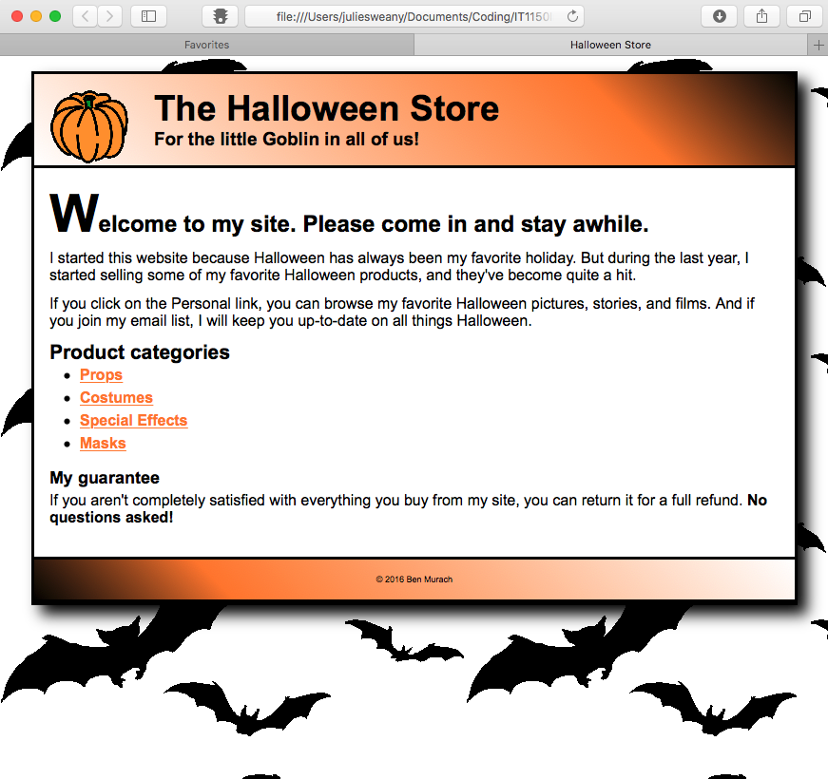The finished page, displayed in the Safari browser, appears below.

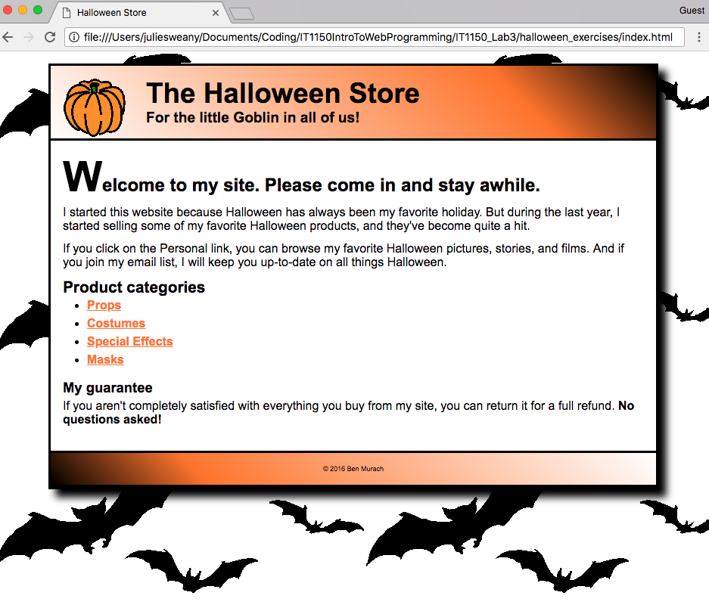The finished page for Halloween 5, displayed Chrome (top) and Firefox (below).

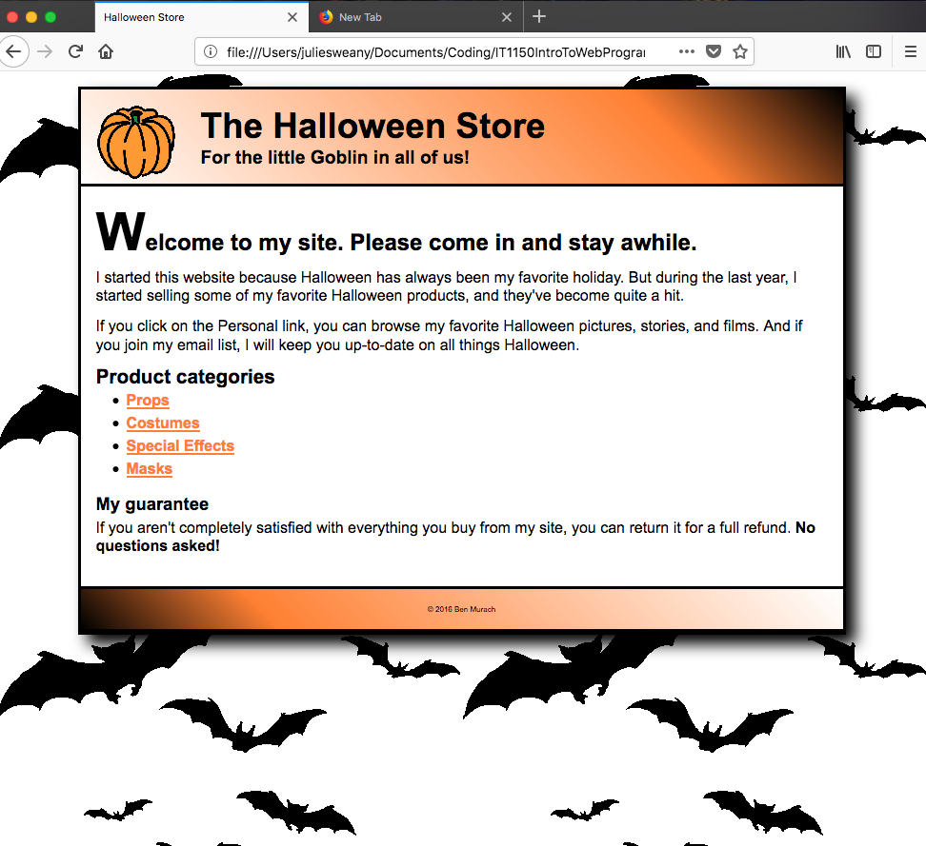 HTML for Halloween Exercise 5

<!DOCTYPE html>

<html lang="en">

<head>

<meta charset="utf-8" />

<title>Halloween Store</title>

<link rel="stylesheet" href="styles/normalize.css">

<link rel="stylesheet" href="styles/main.css">

</head>

<body>

<header>

<img src="images/pumpkin.gif" alt="pumpkin">

<h2>The Halloween Store</h2>

<h3>For the little Goblin in all of us!</h3>

</header>

<main>

<h1><span class="large">W</span>elcome to my site. Please come in and stay awhile.</h1>

<p>I started this website because Halloween has always been my favorite holiday. But during the last year, I started selling some of my favorite Halloween products, and they've become quite a hit.</p>

<p>If you click on the Personal link, you can browse my favorite Halloween pictures, stories, and films. And if you join my email list, I will keep you up-to-date on all things Halloween.</p>

<h2>Product categories</h2>

<ul>

<li><a href="slides/products/props.html">Props</a>

<li><a href="slides/products/costumes.html">Costumes</a>

<li><a href="slides/products/effects.html">Special Effects</a>

<li><a href="slides/products/masks.html">Masks</a>

</ul>

<h3>My guarantee</h3>

<p>If you aren't completely satisfied with everything you buy from my site, you can return it for a full refund.

<b>No questions asked!</b></p>

</main>

<footer>

<p>&copy; 2016 Ben Murach</p>

</footer>

</body>

</html>

The CSS for Halloween Exercise 5

/* reset selector */

* {

margin: 0;

padding: 0;

}

/* style for background behind body */

html {

background-image: url("../images/bats.gif")

}

/* the styles for the elements */

body {

font-family: Arial, Helvetica, sans-serif;

font-size: 100%;

width: 800px;

background-color: white;

margin: 1em auto;

border: 3px solid black;

box-shadow: 10px 10px 15px black;

}

/* the styles for the header */

header img {

float: left;

}

header h2 {

font-size: 230%;

text-indent: 25px;

}

header h3 {

font-size: 120%;

text-indent: 25px;

}

header {padding: 1em;

border-bottom: 3px solid black;

background-image: linear-gradient(45deg, #ffffff 0%, #FF8033 75%, #000000 100%);

background-image: -webkit-linear-gradient(45deg, #ffffff 0%, #FF8033 75%, #000000 100%);

background-image: -moz-linear-gradient(45deg, #ffffff 0%, #FF8033 75%, #000000 100%);

background-image: -o-linear-gradient(45deg, #ffffff 0%, #FF8033 75%, #000000 100%);

}

/* the styles for the section */

main {

clear: left;

margin: 0 1em 2em;

}

main h1 {

font-size: 150%;

margin-bottom: .25em;

}

main h2 {

font-size: 130%;

}

main h3 {

margin: .75em 0 .25em;

font-size: 115%;

}

main ul {

line-height: 1.5;

}

main li {

margin-left: 2em;

}

main p {

margin-bottom: .75em;

}

/* style for a class */

.large {

font-size: 230%;

}

/* the styles for links */

a:link, a:focus, a:visited {

font-weight: bold;

color: #FF8033;

}

a:hover {

color: green;

}

/* the styles for the footer */

footer {

border-top: 3px solid black;

padding: 1em;

border-bottom: 3px solid black;

background-image: linear-gradient(45deg, #000000 0%, #FF8033 25%, #FFFFFF 100%);

background-image: -webkit-linear-gradient(45deg, #000000 0%, #FF8033 25%, #FFFFFF 100%);

background-image: -moz-linear-gradient(45deg, #000000 0%, #FF8033 25%, #FFFFFF 100%);

background-image: -o-linear-gradient(45deg, #000000 0%, #FF8033 25%, #FFFFFF 100%);

}

footer p {

text-align: center;

font-size: 50%;

}

# Chapter 6, Exercises 6-1 and 6-2

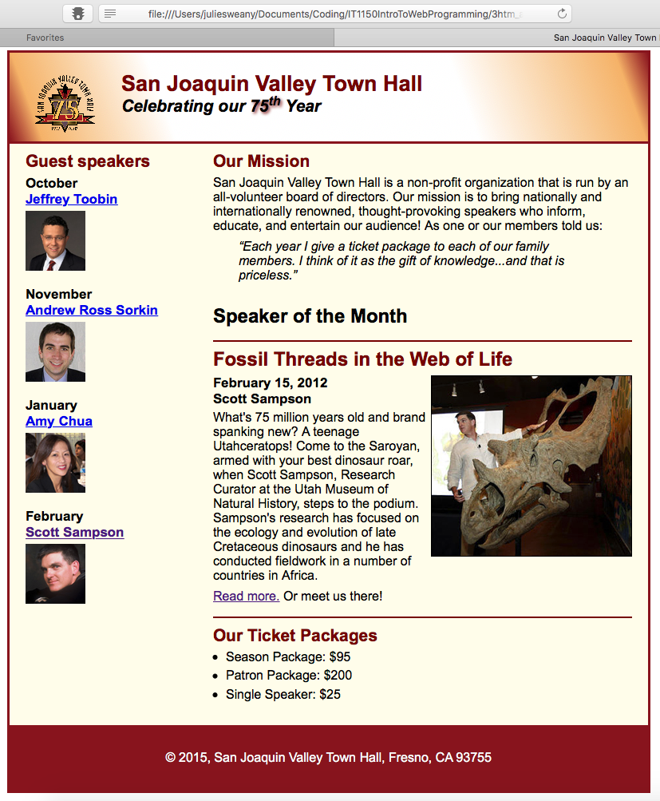These exercises added a more complicated layout to the existing Town Hall web page. Within the HTML for the page, a section and an aside were assigned and floated side by side to create the two vertical sections of the layout. Additionally, within the section, an article was designated. Creating the article allowed for easy customizing of that portion of the layout, such as the addition of the top and bottom border and changes to the h2 and p elements. For the most part, the other changes that were specified covered concepts addressed in previous exercises, reinforcing those concepts.

A screenshot displaying the finished page for Exercises   
6-1 and 6-2, viewed in Safari.

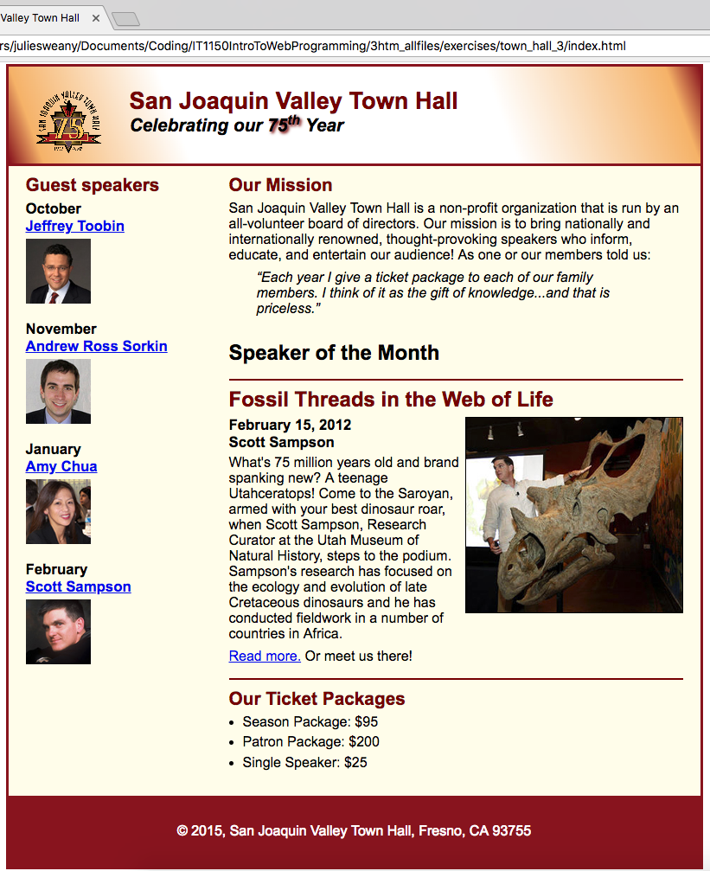Screenshots displaying the finished page for Exercises 6-1 and 6-2 in Chrome (to the left) and Firefox (below).

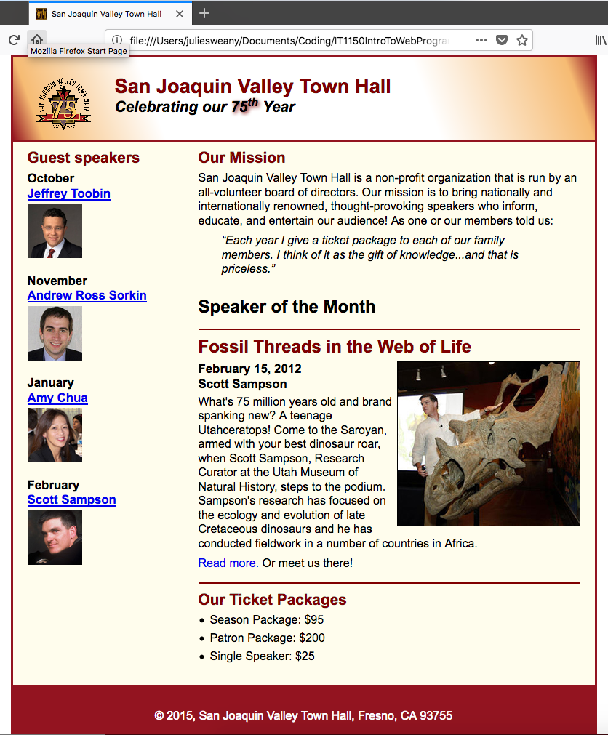

The HTML for Chapter 6, Exercises 6-1 and 6-2

<!DOCTYPE html>

<html lang="en">

<head>

<meta charset="utf-8">

<title>San Joaquin Valley Town Hall</title>

<link rel="shortcut icon" href="images/favicon.ico">

<link rel="stylesheet" href="styles/normalize.css">

<link rel="stylesheet" href="styles/main.css">

</head>

<body>

<header>

<img src="images/town_hall_logo.gif" alt="Town Hall Logo" height="80">

<h2>San Joaquin Valley Town Hall</h2>

<h3>Celebrating our <span class="shadow">75<sup>th</sup></span> Year</h3>

</header>

<main>

<section>

<h2>Our Mission</h2>

<p>San Joaquin Valley Town Hall is a non-profit organization that is run by an all-volunteer board of directors. Our mission is to bring nationally and internationally renowned, thought-provoking speakers who inform, educate, and entertain our audience! As one or our members told us:</p>

<blockquote>&ldquo;Each year I give a ticket package to each of our family members. I think of it as the gift of knowledge...and that is priceless.&rdquo;</blockquote>

<h1>Speaker of the Month</h1>

<article>

<h2>Fossil Threads in the Web of Life</h2>

<img src="images/sampson_dinosaur.jpg" alt="Sampson and dinosaur">

<h3>February 15, 2012<br>

Scott Sampson</h3>

<p>What's 75 million years old and brand spanking new? A teenage Utahceratops! Come to the Saroyan, armed with your best dinosaur roar, when Scott Sampson, Research Curator at the Utah Museum of Natural History, steps to the podium. Sampson's research has focused on the ecology and evolution of late Cretaceous dinosaurs and he has conducted fieldwork in a number of countries in Africa.</p>

<p><a href="speakers/sampson.html">Read more.</a> Or meet us there!</p>

</article>

<h2>Our Ticket Packages</h2>

<ul>

<li>Season Package: $95</li>

<li>Patron Package: $200</li>

<li>Single Speaker: $25</li>

</ul>

</section>

<aside>

<h2>Guest speakers</h2>

<h3>October<br><a href="speakers/toobin.html">Jeffrey Toobin</a></h3>

<img src="images/toobin75.jpg" alt="Toobin Photo">

<h3>November<br><a href="speakers/sorkin.html">Andrew Ross Sorkin</a></h3>

<img src="images/sorkin75.jpg" alt="Sorkin Photo">

<h3>January<br><a href="speakers/chua.html">Amy Chua</a></h3>

<img src="images/chua75.jpg" alt="Chua Photo">

<h3>February<br><a href="speakers/sampson.html">Scott Sampson</a></h3>

<img src="images/sampson75.jpg" alt="Sampson Photo">

</aside>

</main>

<footer>

<p>&copy; 2015, San Joaquin Valley Town Hall, Fresno, CA 93755</p>

</footer>

</body>

</html>

The CSS for Chapter 6, Exercises 6-1 and 6-2

/* reset selector */

* {

margin: 0;

padding: 0;

}

/* the styles for the elements */

html {

background-color: #ffffff;

}

body {

background-color: #fffded;

width: 800px;

margin: 1em auto 1em;

border: 3px solid #931420;

font-family: Arial, Helvetica, sans-serif;

font-size: 100%;

}

section {

width: 525px;

float: right;

}

aside {

width: 215px;

float: right;

padding: 0 0 20px 20px;

}

footer {

background-color: #931420;

padding: 1em;

clear: both;

}

/* the styles for the header */

header {

background-image: linear-gradient(20deg, #931420 0%, #f6bb73 5%, #ffffff 25%,

#ffffff 70%, #f6bb73 95%, #931420 100%);

background-image: -webkit-linear-gradient(20deg, #931420 0%, #f6bb73 5%, #ffffff 25%, #ffffff 70%, #f6bb73 95%, #931420 100%);

background-image: -moz-linear-gradient(20deg, #931420 0%, #f6bb73 5%, #ffffff 25%, #ffffff 70%, #f6bb73 95%, #931420 100%);

background-image: -o-linear-gradient(20deg, #931420 0%, #f6bb73 5%, #ffffff 25%, #ffffff 70%, #f6bb73 95%, #931420 100%);

border-bottom: 3px solid #931420;

padding: 1.5em 0 2em;

}

header img {

float: left;

padding: 0 30px 0;

}

header h2 {

font-size: 170%;

color: #800000;

}

header h3 {

font-size: 130%;

font-style: italic;

}

.shadow {

text-shadow: 2px 2px 4px #800000;

}

/* the styles for the section */

section {

clear: left;

padding: 0 20px 20px;

}

section h1 {

font-size: 150%;

padding: .5em 0 .0;

}

section h2 {

font-size: 130%;

color: #800000;

padding: .5em 0 .25em;

}

section p {

padding-bottom: .5em;

}

section blockquote {

padding: 0 2em 0;

font-style: italic;

}

aside h3 {

font-size: 105%;

padding-bottom: .25em;

}

aside img {

padding-bottom: 1em;

}

aside h2 {

font-size: 130%;

color: #800000;

padding: .5em 0 .25em;

}

section ul {

padding: 0 0 .25em 1em;

}

section li {

padding-bottom: .35em;

}

/* the styles for links */

a:hover, a:focus {

font-style: italic;

}

article {

padding: .5em 0 .5em;

border-top: 2px solid #800000;

border-bottom: 2px solid #800000;

}

article img {

float: right;

border: 1px solid #000000;

}

article h1 {

font-size: 150%;

padding: .5em 0 .25em;

}

article h2 {

font-size: 150%;

padding: 0 0 .25em;

}

article h3 {

font-size: 105%;

padding: 0 0 .25em;

}

/* the styles for the footer */

footer p {

text-align: center;

color: white;

padding: 1em 0;

}

# Chapter 6, Exercise 6-3

A child page based on the home page for the Town Hall web site was created for Exercise 6-3. This further reinforced the concept of using sections and floats to create more complex layouts and provided additional practice using skills learned in previous lessons.

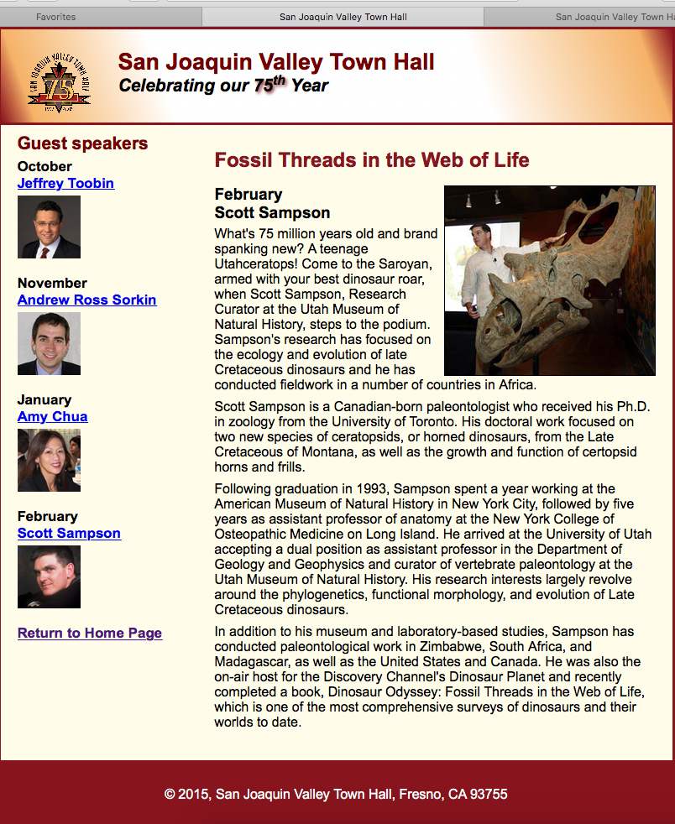A screenshot displaying the finished page for Exercise 6-3, viewed in Safari.

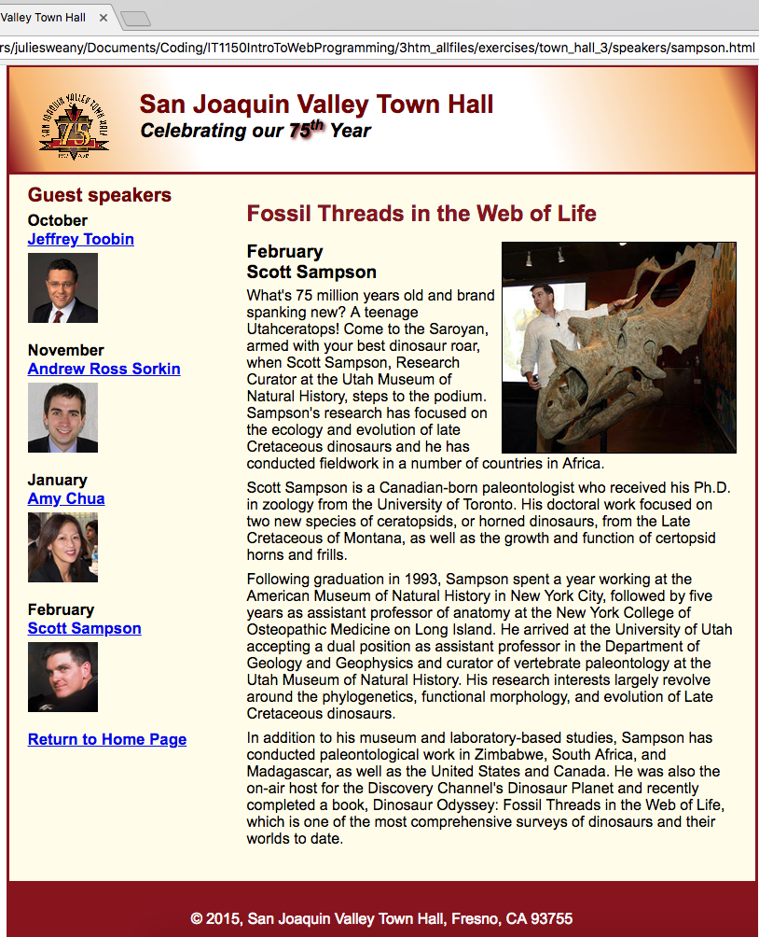Screenshots showing   
the finished page for   
Exercise 6-3 in Chrome   
(to the left) and Firefox (below).

Differences between the various browsers were, as usual, very slight.

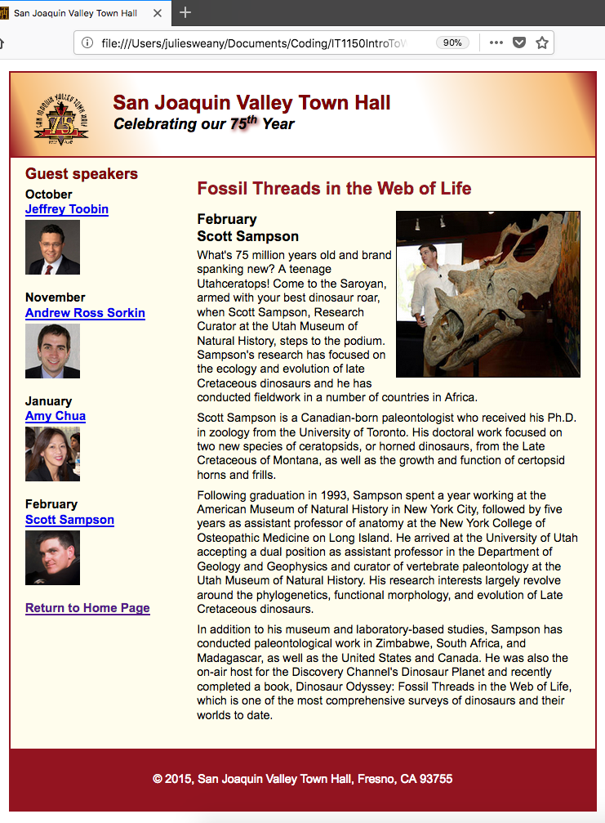

The HTML for Chapter 6, Exercises 6-3

<!DOCTYPE html>

<html lang="en">

<head>

<meta charset="utf-8">

<title>San Joaquin Valley Town Hall</title>

<link rel="shortcut icon" href="../images/favicon.ico">

<link rel="stylesheet" href="../styles/normalize.css">

<link rel="stylesheet" href="../styles/sampson.css">

</head>

<body>

<header>

<img src="../images/town_hall_logo.gif" alt="Town Hall Logo" height="80">

<h2>San Joaquin Valley Town Hall</h2>

<h3>Celebrating our <span class="shadow">75<sup>th</sup></span> Year</h3>

</header>

<main>

<section>

<h1>Fossil Threads in the Web of Life</h1>

<article>

<img src="../images/sampson_dinosaur.jpg" alt="Sampson with dinosaur">

<h2>February<br>

Scott Sampson</h2>

<p>What's 75 million years old and brand spanking new? A teenage Utahceratops! Come to the

Saroyan, armed with your best dinosaur roar, when Scott Sampson, Research Curator at the

Utah Museum of Natural History, steps to the podium. Sampson's research has focused on the

ecology and evolution of late Cretaceous dinosaurs and he has conducted fieldwork in a number

of countries in Africa.</p>

<p>Scott Sampson is a Canadian-born paleontologist who received his Ph.D. in zoology from the

University of Toronto. His doctoral work focused on two new species of ceratopsids, or horned

dinosaurs, from the Late Cretaceous of Montana, as well as the growth and function of certopsid

horns and frills.</p>

<p>Following graduation in 1993, Sampson spent a year working at the American Museum of Natural

History in New York City, followed by five years as assistant professor of anatomy at the New

York College of Osteopathic Medicine on Long Island. He arrived at the University of Utah

accepting a dual position as assistant professor in the Department of Geology and Geophysics

and curator of vertebrate paleontology at the Utah Museum of Natural History. His research

interests largely revolve around the phylogenetics, functional morphology, and evolution of

Late Cretaceous dinosaurs.</p>

<p>In addition to his museum and laboratory-based studies, Sampson has conducted paleontological

work in Zimbabwe, South Africa, and Madagascar, as well as the United States and Canada. He was

also the on-air host for the Discovery Channel's Dinosaur Planet and recently completed a book,

Dinosaur Odyssey: Fossil Threads in the Web of Life, which is one of the most

comprehensive surveys of dinosaurs and their worlds to date.</p>

</article>

</section>

<aside>

<h2>Guest speakers</h2>

<h3>October<br><a href="speakers/toobin.html">Jeffrey Toobin</a></h3>

<img src="../images/toobin75.jpg" alt="Toobin Photo">

<h3>November<br><a href="speakers/sorkin.html">Andrew Ross Sorkin</a></h3>

<img src="../images/sorkin75.jpg" alt="Sorkin Photo">

<h3>January<br><a href="speakers/chua.html">Amy Chua</a></h3>

<img src="../images/chua75.jpg" alt="Chua Photo">

<h3>February<br><a href="speakers/sampson.html">Scott Sampson</a></h3>

<img src="../images/sampson75.jpg" alt="Sampson Photo">

<h3><a href="../index.html">Return to Home Page</a></h3>

</aside>

</main>

<footer>

<p>&copy; 2015, San Joaquin Valley Town Hall, Fresno, CA 93755</p>

</footer>

</body>

</html>

The CSS for Chapter 6, Exercises 6-3

/* reset selector */

* {

margin: 0;

padding: 0;

}

/* the styles for the elements */

html {

background-color: #ffffff;

}

body {

background-color: #fffded;

width: 800px;

margin: 1em auto 1em;

border: 3px solid #931420;

font-family: Arial, Helvetica, sans-serif;

font-size: 100%;

}

section {

width: 525px;

float: right;

}

aside {

width: 215px;

float: right;

padding: 0 0 20px 20px;

}

footer {

background-color: #931420;

padding: 1em;

clear: both;

}

/* the styles for the header */

header {

background-image: linear-gradient(20deg, #931420 0%, #f6bb73 5%, #ffffff 25%,

#ffffff 70%, #f6bb73 95%, #931420 100%);

background-image: -webkit-linear-gradient(20deg, #931420 0%, #f6bb73 5%, #ffffff 25%, #ffffff 70%, #f6bb73 95%, #931420 100%);

background-image: -moz-linear-gradient(20deg, #931420 0%, #f6bb73 5%, #ffffff 25%, #ffffff 70%, #f6bb73 95%, #931420 100%);

background-image: -o-linear-gradient(20deg, #931420 0%, #f6bb73 5%, #ffffff 25%, #ffffff 70%, #f6bb73 95%, #931420 100%);

border-bottom: 3px solid #931420;

padding: 1.5em 0 2em;

}

header img {

float: left;

padding: 0 30px 0;

}

header h2 {

font-size: 170%;

color: #800000;

}

header h3 {

font-size: 130%;

font-style: italic;

}

.shadow {

text-shadow: 2px 2px 4px #800000;

}

/* the styles for the section */

section {

clear: left;

padding: 0 20px 20px;

}

section h1 {

font-size: 150%;

padding: .5em 0 .0;

color: #931420;

}

section h2 {

font-size: 130%;

color: #800000;

padding: .5em 0 .25em;

}

section p {

padding-bottom: .5em;

}

section blockquote {

padding: 0 2em 0;

font-style: italic;

}

aside h3 {

font-size: 105%;

padding-bottom: .25em;

}

aside img {

padding-bottom: 1em;

}

aside h2 {

font-size: 130%;

color: #800000;

padding: .5em 0 .25em;

}

section ul {

padding: 0 0 .25em 1em;

}

section li {

padding-bottom: .35em;

}

/* the styles for links */

a:hover, a:focus {

font-style: italic;

}

article {

padding: 0 0 .5em;

}

article img {

float: right;

border: 1px solid #000000;

}

article h1 {

font-size: 150%;

padding: .5em 0 0;

}

article h2 {

font-size: 120%;

padding: 0 0 .25em;

color: #000000;

}

article h3 {

font-size: 105%;

padding: 0 0 .25em;

}

/* the styles for the footer */

footer p {

text-align: center;

color: white;

padding: 1em 0;

}

# Halloween Exercise, Part 2

This exercise again dealt with creating and floating different sections in order to create a layout for the web page. This time, however, the directions asked that one of the sections be set up as a class named “sidebar”. Using id="sidebar" within the opening HTML tag for the aside created the class. Then, in the CSS, the selector #sidebar was used when creating rule sets for that section.

The final page for Halloween Exercise, Part 2, displayed Safari.

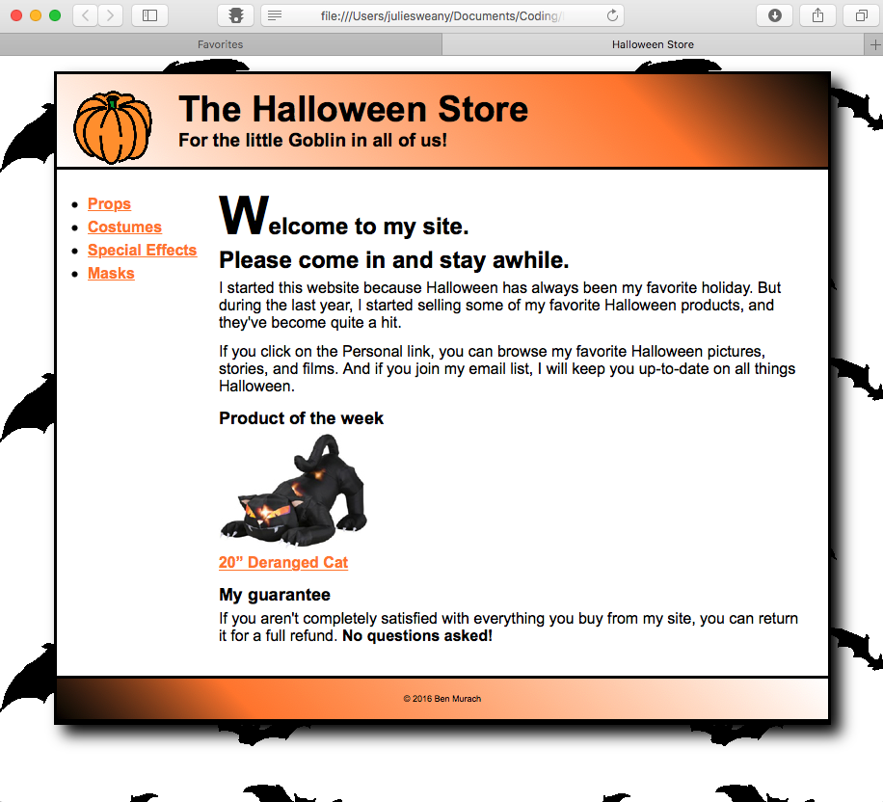

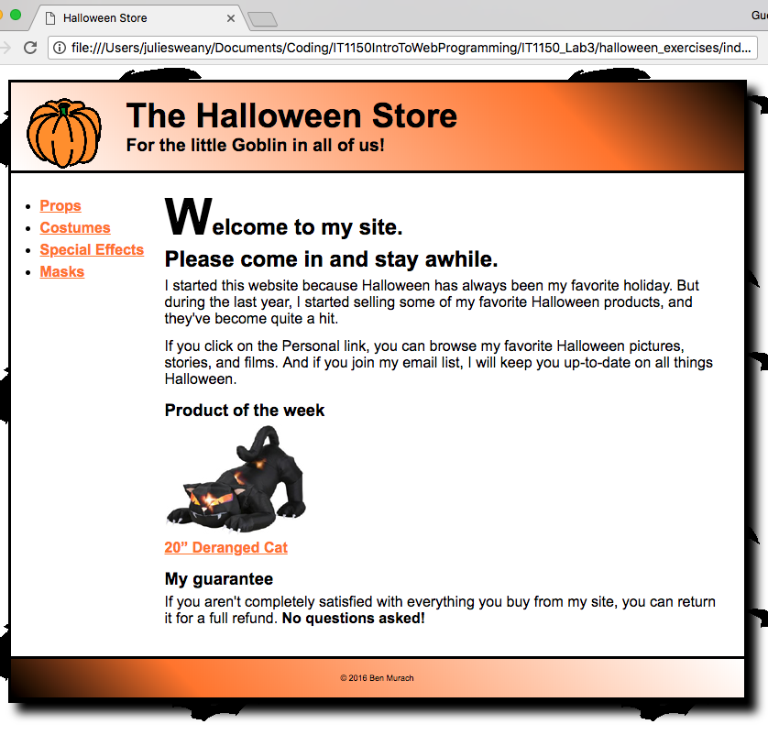The finished page for Halloween Exercise Part 2 displayed in Chrome (on the left) Firefox (below). There was very little difference in the display of the various browsers.

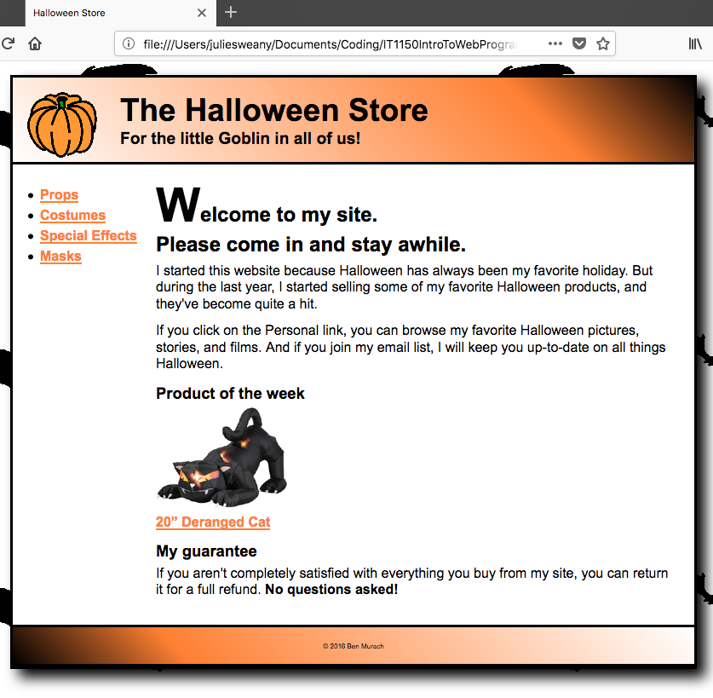

The HTML code for Halloween Exercise, Part 2

<!DOCTYPE html>

<html lang="en">

<head>

<meta charset="utf-8" />

<title>Halloween Store</title>

<link rel="stylesheet" href="styles/normalize.css">

<link rel="stylesheet" href="styles/main.css">

</head>

<body>

<header>

<img src="images/pumpkin.gif" alt="pumpkin">

<h2>The Halloween Store</h2>

<h3>For the little Goblin in all of us!</h3>

</header>

<aside id="sidebar">

<ul>

<li><a href="slides/products/props.html">Props</a>

<li><a href="slides/products/costumes.html">Costumes</a>

<li><a href="slides/products/effects.html">Special Effects</a>

<li><a href="slides/products/masks.html">Masks</a>

</ul>

</aside>

<section>

<h1><span class="large">W</span>elcome to my site.<br>Please come in and stay awhile.</h1>

<p>I started this website because Halloween has always been my favorite holiday. But during the last year, I started selling some of my favorite Halloween products, and they've become quite a hit.</p>

<p>If you click on the Personal link, you can browse my favorite Halloween pictures, stories, and films. And if you join my email list, I will keep you up-to-date on all things Halloween.</p>

<h3>Product of the week</h3>

<img src="images/cat1.jpg" alt="cat"><br>

<a href="slides/products/cat.html">20&rdquo; Deranged Cat</a>

<h3>My guarantee</h3>

<p>If you aren't completely satisfied with everything you buy from my site, you can return it for a full refund.

<b>No questions asked!</b></p>

</section>

<footer>

<p>&copy; 2016 Ben Murach</p>

</footer>

</body>

</html>The CSS for Halloween Exercise, Part 2

/* reset selector */

* {

margin: 0;

padding: 0;

}

/* style for background behind body */

html {

background-image: url("../images/bats.gif")

}

/* the styles for the elements */

body {

font-family: Arial, Helvetica, sans-serif;

font-size: 100%;

width: 800px;

background-color: white;

margin: 1em auto;

border: 3px solid black;

box-shadow: 10px 10px 15px black;

}

/* the styles for the header */

header img {

float: left;

}

header h2 {

font-size: 230%;

text-indent: 25px;

}

header h3 {

font-size: 120%;

text-indent: 25px;

}

header {padding: 1em;

border-bottom: 3px solid black;

background-image: linear-gradient(45deg, #ffffff 0%, #FF8033 75%, #000000 100%);

background-image: -webkit-linear-gradient(45deg, #ffffff 0%, #FF8033 75%, #000000 100%);

background-image: -moz-linear-gradient(45deg, #ffffff 0%, #FF8033 75%, #000000 100%);

background-image: -o-linear-gradient(45deg, #ffffff 0%, #FF8033 75%, #000000 100%);

}

/* the styles for the sidebar */

#sidebar {

float: left;

margin: 1.5em .5em 0 0;

width: 160px;

height: 500px;

}

#sidebar ul {

line-height: 1.5;

}

#sidebar li {

margin-left: 2em;

}

/* the styles for the section */

section {

margin: 0 1.5em 2em;

}

section h1 {

font-size: 150%;

margin-bottom: .25em;

}

section h2 {

font-size: 130%;

}

section h3 {

margin: .75em 0 .25em;

font-size: 115%;

}

section p {

margin-bottom: .75em;

}

/* style for a class */

.large {

font-size: 230%;

}

/* the styles for links */

a:link, a:focus, a:visited {

font-weight: bold;

color: #FF8033;

}

a:hover {

color: green;

}

/* the styles for the footer */

footer {

clear: both;

border-top: 3px solid black;

padding: 1em;

border-bottom: 3px solid black;

background-image: linear-gradient(45deg, #000000 0%, #FF8033 25%, #FFFFFF 100%);

background-image: -webkit-linear-gradient(45deg, #000000 0%, #FF8033 25%, #FFFFFF 100%);

background-image: -moz-linear-gradient(45deg, #000000 0%, #FF8033 25%, #FFFFFF 100%);

background-image: -o-linear-gradient(45deg, #000000 0%, #FF8033 25%, #FFFFFF 100%);

}

footer p {

text-align: center;

font-size: 50%;

}

# Conclusion

Coming from a background in graphic design, it’s not surprising that I enjoyed working with the more complex layouts for the exercises in this lab. I find the concepts of the box model and establishing floats in CSS fairly straightforward (although it does take a little trial and error to get the exact desired spacing sometimes).

It’s also becoming clear that organization and establishing a systematic way of styling elements will be very important when working with larger sites. I find it interesting that in HTML and CSS, there is often more than one way of achieving an effect. That can be convenient, yet it can also make things a little confusing at times. I suspect that more experienced developers settle into habits of using the same methods repeatedly, unless there is a good reason to make an exception.

It will be interesting to gain more experience with layout, and other concepts, as the semester progresses.

# Resources

Boehm, Anne and Ruvalcaba, Zak. *Murach’s HTML5 and CSS3* 3rd ed. Mike Murach &   
 Associates, Inc. 2015